# (U) Development of Optimized Chaff Using the Method of Moments

## (U) Abstract

## (U) Research Innovation and Objective(s): In 100 words or less, articulate why the research is innovative (compared to the current SOA) and what are you trying to accomplish. What are your objectives?

Innovative software tools were developed that enable new predictive engineering designs of chaff that were not possible before. This allows for the design of broadband chaff.

## (U) Impacts on Warfighter Mission: In 100 words or less, explain how the research will impact the effectiveness, performance, and mission of the warfighter.

## (U) Keywords: Method of Moments (MoM), Perfectly Electrically Conducting Plate (PEC), Printed Chaff, Electrical Integral Field Equation (EFIE)

## (U) Nomenclature

## 1. (U) Introduction

(U) Active Radar Homing (ARH) is used for missile guidance to track, target, and defeat aircrafts. Chaff was a solution was developed by Joan Curran at Redstone Arsenal during World War II that is still in use. Metal fibers and aluminized paper strips are cut to half a wavelength in size to optimize radiation at a certain frequency. When a large amount of chaff is dropped, the cloud appears as a large primary target camouflage friendly forces [1].

(U) Past manufacturing techniques have limited design. The original metal fiber and aluminized paper strips are only optimized at one frequency. Metal ink printing is a new manufacturing technology that can be used to develop printed metal flakes to be used as chaff. The flakes would have all the benefits of good chaff including biodegradable, lightweight, and easy to disseminate while allowing modification to the shape the metal for optimization. Introducing this new parameter gives the opportunity to improve scattering over a large frequency range.

(U) Antenna shape synthesis is a current area of research that can be applied to chaff design [2-5]. In shape synthesis, the shape of the antenna is changed optimizing radiation over user-selected frequency bands. A novel approach was developed to predict performance of printed metal chaff flakes using shape synthesis. Printed flakes offer all the necessary properties of chaff including large backscattering, biodegradable, easy to handle and disseminate, non-hazardous, and affordable while allowing optimization over selected frequency bands.

(U) To begin, a method of moments approach is used to generate a Perfectly Conducting (PEC) square plate meant to model the printed chaff. MoM is ideally suited for this problem because the full geometry of the plate only needs to be solved once and is stored in the impedance matrix. This makes modifying the shape of the plate a simple operation of removing corresponding rows and columns in the impedance matrix. For each generation in the optimization protocol, the impedance matrix needs to be modified once and the radar cross section for multiple incident angles can be calculated. This method has shown to be computationally efficient generating designs in reasonable amount of time.

## 2. (U) Method

(U) In this section, a method of moment’s approach will be explained. First, a flat square perfectly conducting plate (PEC) formulation will be given. Then holes will be created by modifying the impedance matrix. Finally, the optimization algorithm will be described.

### 2.1 (U) Method of Moments for a Flat Square PEC plate

(U) The method of moment formulation for a flat perfectly conducting square plate is well documented. For convince of the reader, a brief overview is given here, however for a more rigorous explanation please refer to [PETERSON REF].

(U) To begin, we start with the Electric Field Integral (EFIE) equation [EFIE EQ]. Taking advantage of the square geometry, the plate is broken into equal sized squares of length *a* that will be referred to as cells.

(U) The current is expanded into a series representation using the well-known “roof-top” basis functions [CURRENT EXPANSION EQ] that is centered on the edge between two cells at the point ). To deal with polarization, the current will be split into x-directed and y-directed current. The point’s locations for each polarization are shown in [Jx BASIS FIG] and [Jy BASIS FIG].

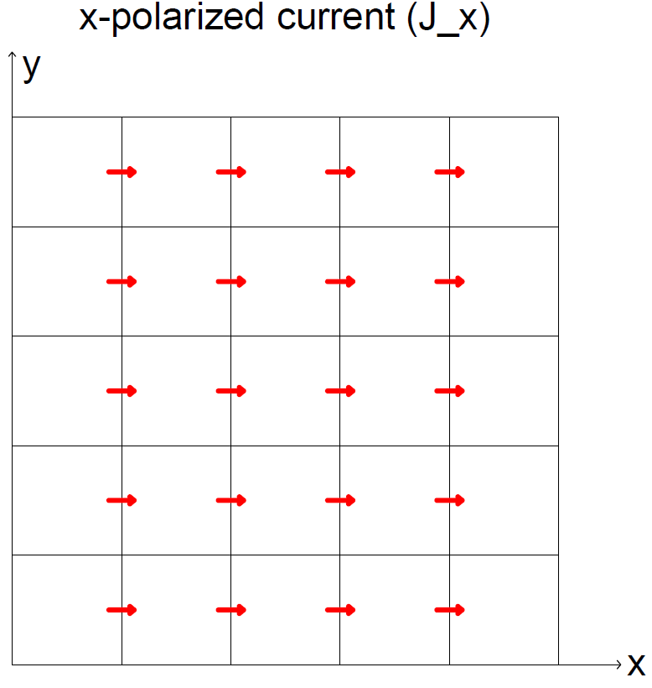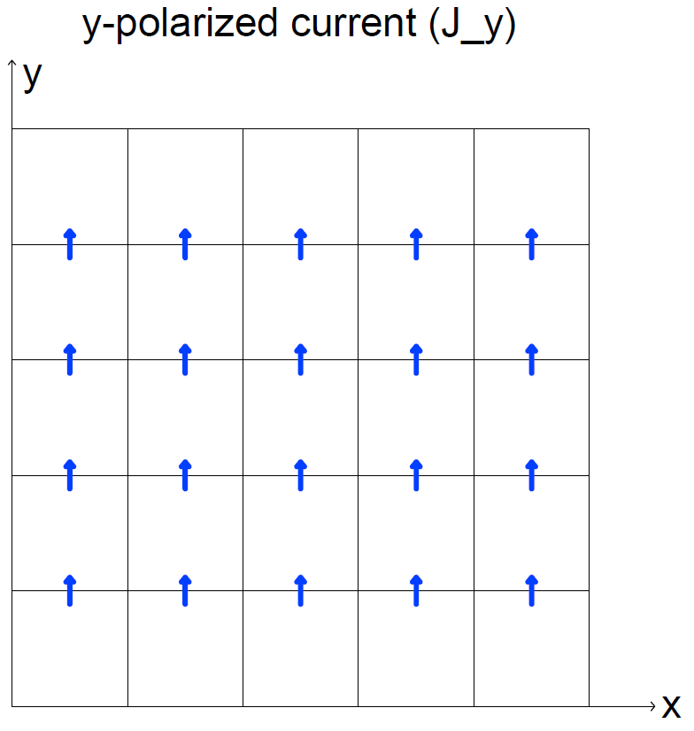

**(U) Figure [CURENT BASIS FIG]:** 5x5 cell plate shown.is shown to the right and center points

(U) To create the N-equations necessary to solve the N-unknowns, the expansion is tested with the “razor blade” function defined in [RAZOR BLAD EQ]. Following these calculations will give the impedance matrix and the PEC plate is fully described [PETERSON REF]. Both the basis and testing function are shown below.

(U) Plugging these equations in generates a linear matrix equation. To solve for the plate currents, the inverse of the impedance matrix is multiplied by the incident field. This form is advantageous, because the geometry of the plate is fully described in **.** This means that to modify the plate geometry, only the impedance matrix needs to be modified. This scheme will be fully described in 2.3.

### (U) Radar Cross section

(U) An equation for the radar cross section is needed. Using definition of the bistatic radar cross section [EQUATION RCS] and plugging in the current given in [CURRENT EXPANSION EQ] leads to the expression [PLATE RCS]. M is the number of basis function for Jx while N is total number of basis functions. The length of the an individual cell is .

### 2.3 (U) Creating holes in the plate

(U) To maximize the Radar Cross Section (RCS), holes will need to be placed strategically. This section describes that process.

(U) Holes can easily be generated by removing the appropriate element from the impedance matrix. The plate has been defined as a grid of cells. Each cell is surrounded by four edges that corresponds to rows and columns in the impedance. To remove a cell, the corresponding edges need to be found and then removed from the impedance matrix.

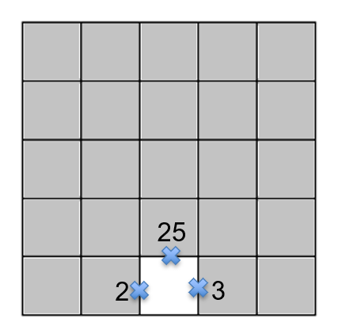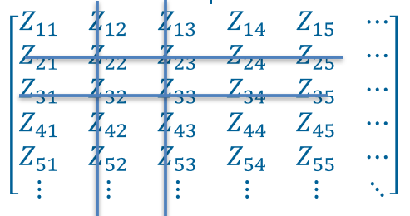

**(U) Figure [EDGE REM]:** 5x5 cell plate. Grey is PEC and white is a hole. Necessary edge numbering is shown to remove the cell and the corresponding Z matrix is shown to the left.

(U) For example, in the above picture to remove the middle cell, the corresponding edges are 2,3, and 25. This means those edges no longer exist and cannot be interacting with any other current on the plate. The impedance matrix needs to be updated to represent this and can be done by removing the second, third, and twenty-fifth column and row.

(U) Single cells cannot be considered on their own. This leads to the case where a single cell is surrounded by holes. This representation implies that current is constant across this area of the plate which is incorrect. Instead, cells are grouped together. This paper will refer to these groupings as pixels. Pixels will then either be “on” (metal) or “off” (hole)

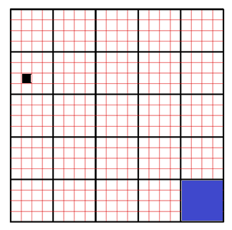

Pixel

Cell

**(U) Figure [PIXAL/CELL FIG]:** A 5x5 pixel plate with 4x4 cells per pixel (20x20 cells total)

### 2.3 (U) Creating holes in the plate

(U) We found that when two pixel corner’s touch our solution did match expected results. Other groups have found this as well [4]. The corners are “touching” and high current flow is expected. However, the current formulation does not allow this phenomenon. Current only flows in x or y, not diagonally. To fix this a single cell can be used to connect the corners.

(U) An example is shown in [PIXEL CORNER FIG] where yellow is metal and blue is a hole. Cell (8,8) is set to be metal. To show the importance of this, the current is generated for 2 inch plate at 8GHz using the 20x20 cell division shown. As seen, a substantial amount of current exist at this corner.

ADD PIC

**(U) Figure [PIXEL CORNER FIG]:** An example of the corner fix. Yellow is metal and blue is a hole. Left picture is pre-fix. Right shows the fix and current flow is shown with arrows.

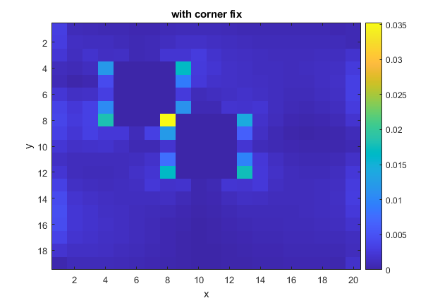

**(U) Figure [CORNER CURRENT FIG]:** current for a 2” plate at 8GHz

### 2.4 (U) Optimization

(U) The algorithm is shown below. To begin, the full PEC plate is generated. Initial conditions then need to be given. These include the frequency range, elevation angles and azimuthal angle of incident wave that the user wishes to optimize at. This is then fed into Matlab’s built-in optimization toolbox.

(U) For each iteration, the impedance matrix is modified to generate holes. We noted that symmetry of the plate is expected. Only 1/8 of the plate needs to be considered. This triangle is then reflected through the chaff design. This can be seen in fig [**KA CHAFF RCS**] The inverse of the impedance matrix is then found and multiplied by the incident wave. The RCS is then calculated and averaged over user specified frequency range and incident wave angles. Essentially, this means that every iteration is removing elements from a matrix and doing multiple matrix multiplications. All these operations are computationally cheap and aid in speeding optimization.

The optimization algorithm continues until an average maximum monostatic RCS is found. The chaff design is then returned to the user.

## 

**(U) Figure [OPTIMIZATION]:** Optimization algorithm

## 3. (U) Results & Discussion

### 3.1 (U) KA-Band Pattern

(U) A KA-band chaff pattern of size 3mm will be presented. The frequencies of interest were 30, 35, and 40 GHZ. The plate was divided into 15x15 pixel pattern that contain 4 cells each or 60x60 cells total. The chaff was illuminated using incident plane wave and divided into twenty discreet points each. The monostatic RCS was sampled at each angle and averaged.

#### 3.1.1 (U) System

(U) The code was run on a Windows 10 personal computer with an Intel® Core™ i7-10700k running at 3.8GHz. 128GB of RAM was installed. The genetic algorithm was employed and took 36.15 hours to complete optimization.

#### 3.1.2 (U) Generated Chaff

The following chaff was generated. The yellow represents metal while blue is a hole. For the choosen optimization parameters, the chaff’s average monostatic RCS was 69% better

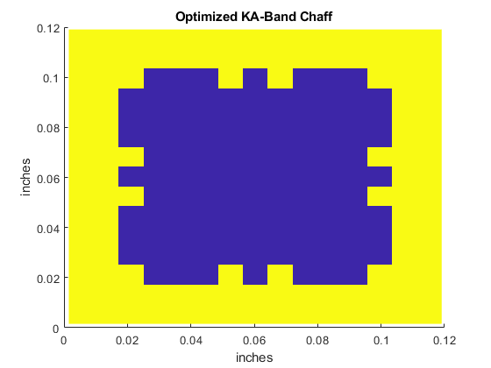

**(U) Figure [KA CHAFF]:** Optimized 3mm Chaff pattern at 30, 35, and 45 GHz. Yellow is printed metal ink while blue is just paper.

#### 3.1.3 (U) Validation

(U) Results were validated using FEKO, a computational electromagnetic software product powered by the Method of Moments integral formulation. Results are shown below.

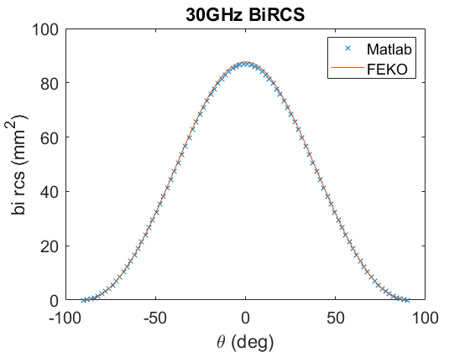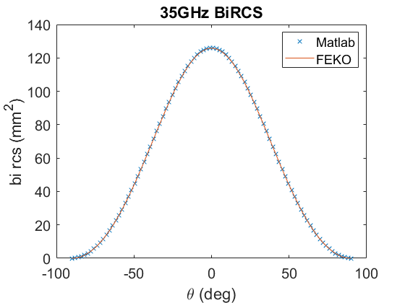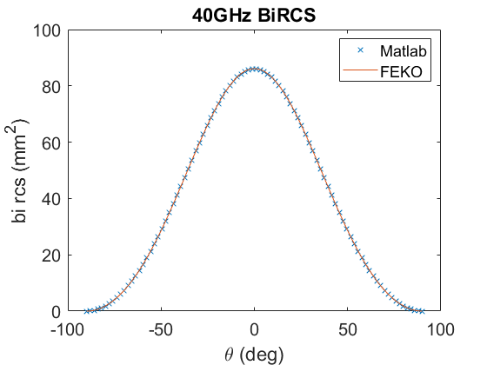

**(U) Figure [KA CHAFF VAL]:** Bistatic RCS of Matlab generated chaff and FEKO to validate answers

#### 3.2.3 (U) Improvement

(U) We found a 69% improvement of the average monostatic RCS at optimized points. For an example, the monoRCS of a plate is shown in comparison to the optimized chaff at incidence. 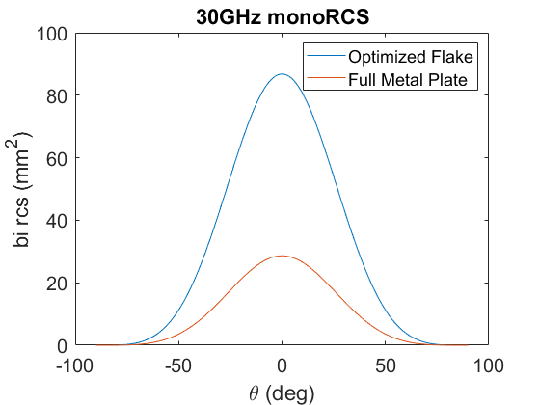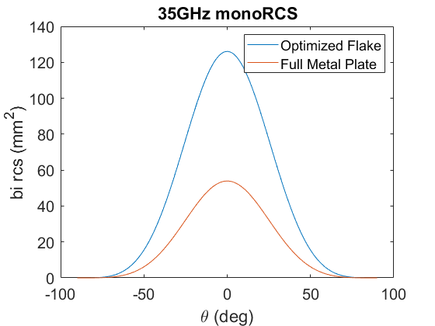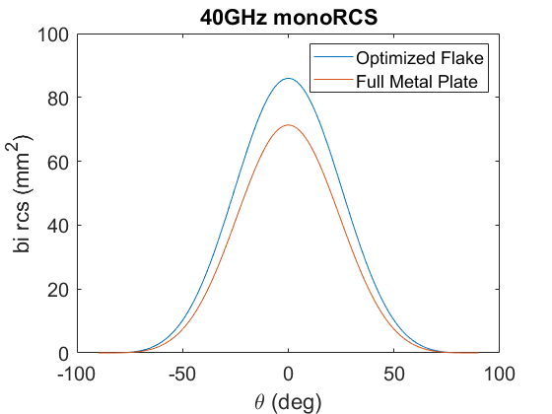

**(U) Figure [KA CHAFF RCS]:** Comparison of optimized chaff and metal plate at zero incidence

## 4. (U) Conclusion

(U) A novel method was demonstrated to optimize a printed chaff design. A method of moments approach was used to model the chaff a PEC square plate. This required breaking the current into x-polarization and y-polarization. The chaff shape was modified by creating holes on the surface to maximize the monostatic radar cross section over a given frequency range and incident angles. A KA-band chaff was presented as an example.

## (U) References

1. Fischer-Hwang, Irena. “The Woman Whose Invention Helped Win a War – and Still Baffles Weathermen” Accessed 07/03/2021. https://www.smithsonianmag.com/innovation/woman-whose-invention-helped-win-warand-still-baffles-weathermen-180970900/
2. Ethier, Jonathan et al. 2014. “Antenna Shape Synthesis Without Prior Specification of the Feedpoint Locations” *IEEE Transactions on Antennas and Propagation*, 62(10).
3. Alakhras, Anas et al. 2021 “The shape synthesis of 3D electrically-small conducting surface antennas” 57(8)
4. Ohira, Masataka eta al. 2004 “Multiband Single-Layer Frequency Selective Surface Designed by Combination of Genetic Algorithm and Geometry-Refinement Technique” *IEEE Transactions on Antennas and Propagation*, 52(11).
5. Aoki, Yuki et al. 2011 “Reflectarray with arbitrarily-shaped conductive elements optimized by genetic algorithm”[*2011 IEEE International Symposium on Antennas and Propagation*](https://ieeexplore-ieee-org.udel.idm.oclc.org/xpl/conhome/5981577/proceeding)
6. Peterson, Andrew; Ray, Scott; Mittra, Ray. *Computational Methods for Electromagnetics.* Oxford University Press, 1998